Assignment 4 - JavaScript Code

- const fs = require("fs");
- const path = require("path"); 3
- // File paths inside the current Assignment 4 folder
- const studentFile = path.join( dirname, "student.txt");
- const studentDetailsFile = path.join( dirname, "studentDetails.txt"); 7
- // Task 1: Create Student Information File
- const studentData = `Name: Sasanka Sekhar Kundu
- Course: Full Stack Development
- Technology: Node.js`;
12
- fs.writeFile(studentFile, studentData, (err) => {
- if (err) {
- console.error("Error creating file:", err);
- return;
17 }
18
19 console.log("File created successfully"); 20
- // Task 2: Read Student Information
- fs.readFile(studentFile, "utf8", (err, data) => {
- if (err) {
- console.error("Error reading file:", err);
- return;
26 }
27
- console.log("\nStudent Information:");
- console.log(data);
30
- // Task 3: Update Student Information
- const additionalData = `
- Experience: 1 Year
- City: Kolkata`;
35
- fs.appendFile(studentFile, additionalData, (err) => {
- if (err) {
- console.error("Error updating file:", err);
- return;
40 }
41
42 console.log("\nData updated successfully"); 43
- // Read updated file
- fs.readFile(studentFile, "utf8", (err, updatedData) => {
- if (err) {
- console.error("Error reading updated file:", err);
- return;
49 }
50

51 | console.log("\nUpdated Student Information:");
52 | console.log(updatedData);
53
54 | // Task 4: Rename File
55 | fs.rename(studentFile, studentDetailsFile, (err) => {
56 | if (err) {
57 | console.error("Error renaming file:", err);
58 | return;
59 | }
60
61 | console.log("\nFile renamed successfully");
62
63 | // Task 5: Delete File
64 | fs.unlink(studentDetailsFile, (err) => {
65 | if (err) {
66 | console.error("Error deleting file:", err);
67 | return;
68 | }
69
70 | console.log("File deleted successfully");
71 | });
72 | });
73 | });
74 | });
75 | });
76 | });
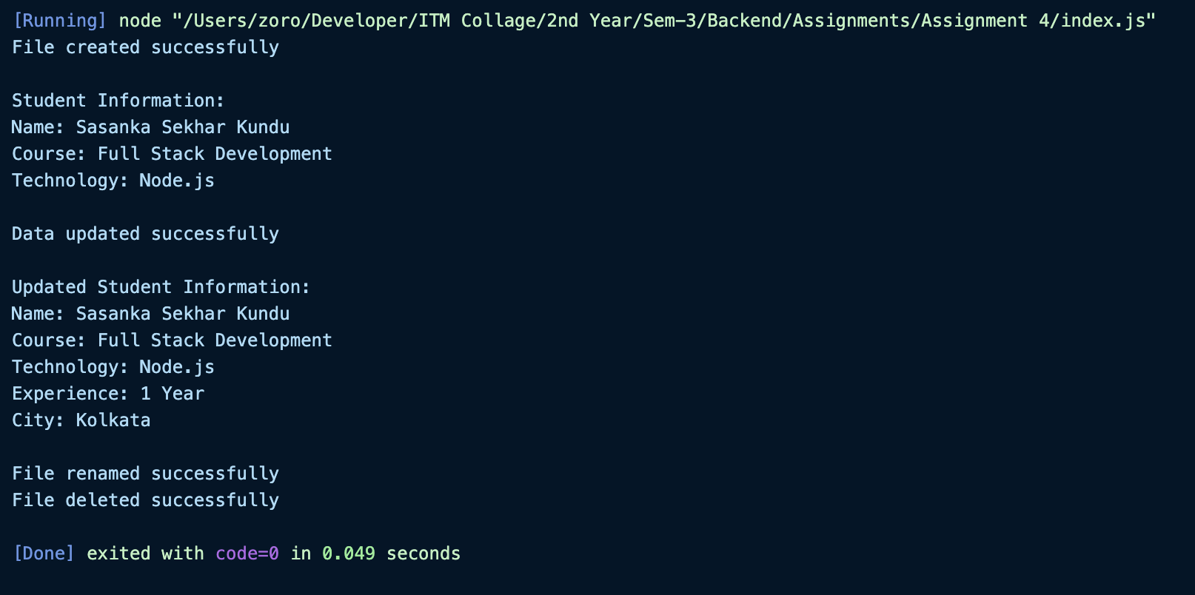
FOLDER STRCUCTURE:
